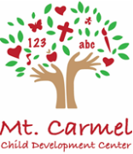

Text Alert System

I will be using a text alert system to inform everyone about delays, closings, (Mt. Carmel) school reminders, or any other information I need to send out. Please do not respond from my text or send me any messages through this system, this is only for me to send out information to all of you at one time. Please return to your child’s teacher as soon as possible!
I will continue to use email for individual conversations. mtcarmelcdc2@gmail.com
Please fill out all information below:
Please write legibly!

1st Child’s Name: __________________________ Teacher: ________________________

2nd Child’s Name: __________________________ Teacher: ________________________

Only two numbers allowed per family

Phone #1: _______________________

Phone #2: _______________________

Date: _____________________________

